AWS Cloud Quest  
**Task 12. Core Security Concepts**

Use IAM to provide work permissions to engineers by using group settings and the least privilege principle.

|  |  |
| --- | --- |
| Person | Hello, and welcome to the city stock exchange. Thanks for answering our call. |
| Me | No problem. How can I help you? |
| Person | We recently added a Support Engineering team, and as this team grows, we want to be able to manage users efficiently, providing all support engineers the same set of permissions. Can AWS help with this? |
| Me | Of course! AWS has a service called IAM. You can use it to create policies that manage AWS users and groups, and you can use permissions to allow and deny access to AWS resources. Using IAM, you can manage your security requirements at scale. |
| Person | So, with policies, do I need to learn every type of permission for all AWS services? I just want my support engineers to have read-only access to Amazon EC2 and Amazon RDS. |
| Me | No, you don't. IAM delivers prebuilt AWS managed policies to help you get started quickly. Two prebuilt policies provide read-only access to Amazon EC2 and Amazon RDS. |
| Person | Great! And if I don't want to use those predefined policies? Can I create my own? |
| Me | Yes, you can create your own custom policy and apply it to your resources. AWS also has tools that can help you create policy files. |
| Person | Sounds like there are lot of options. How about the actual creation of a user? I'd like my support engineers to have access to the AWS Management Console and to developer tools. I also want to assign users to the Support Engineering team right away. |
| Me | When you create users, you can assign them permissions to access resources through the AWS Management Console, AWS CLI, or developer tools. You can also place users in groups and assign permissions. |
| Person | Thanks! This sounds promising!  Can you show us how to get started by creating users and a user group for our Support Engineering Team? |
| Me | Accepted! |
| Person | Thanks so much. Our security team will sleep well knowing that permissions are locked down. |

**Learning Objectives**

* Create an IAM group for support engineers.
* Attach a managed EC2 read-only access policy to the IAM group.
* Create and attach a user to the group.

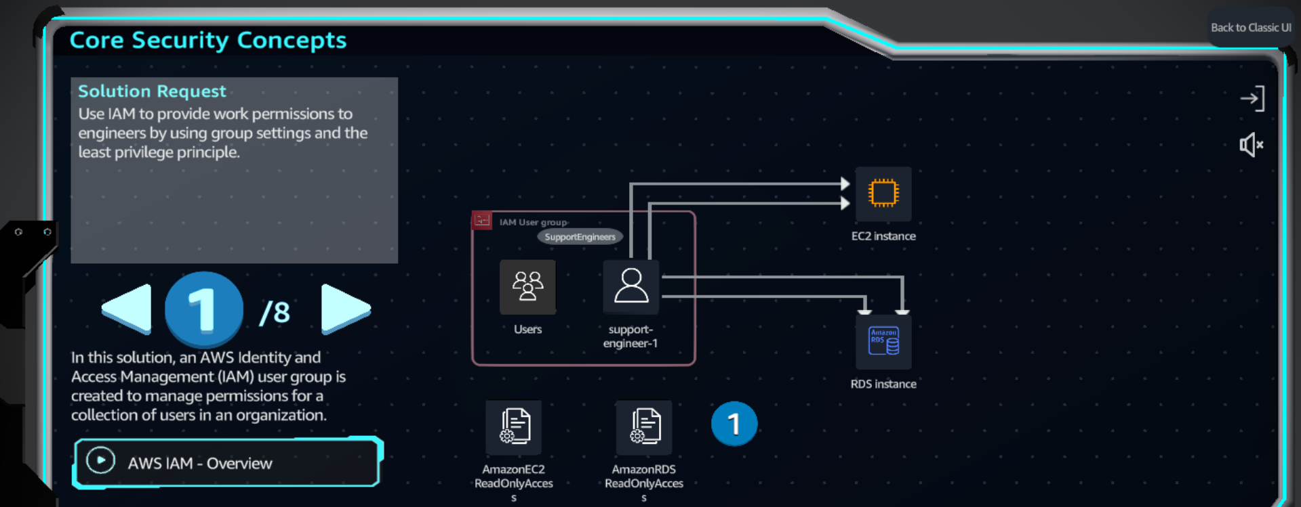 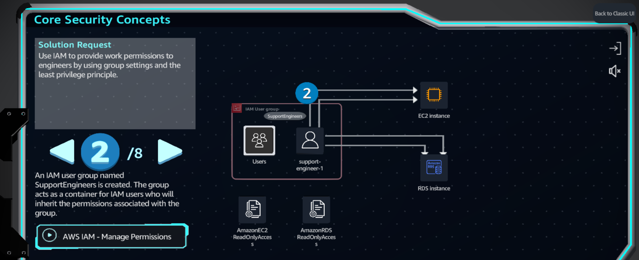 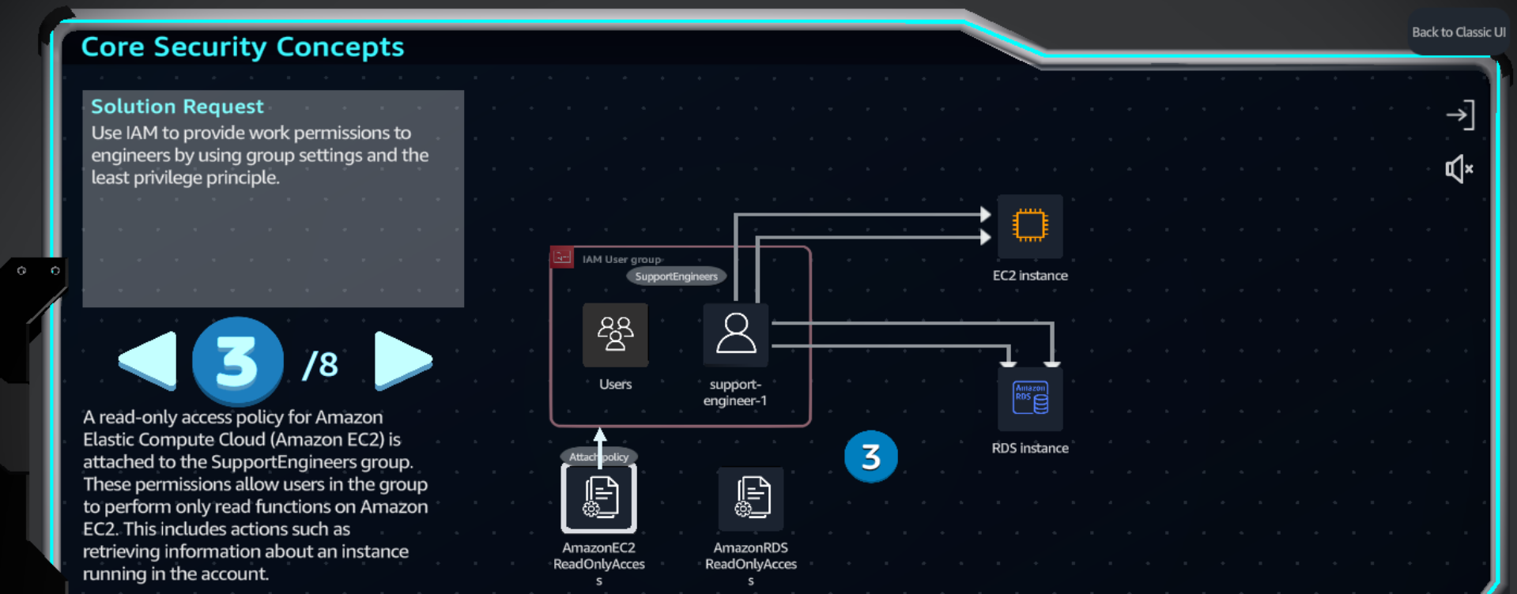

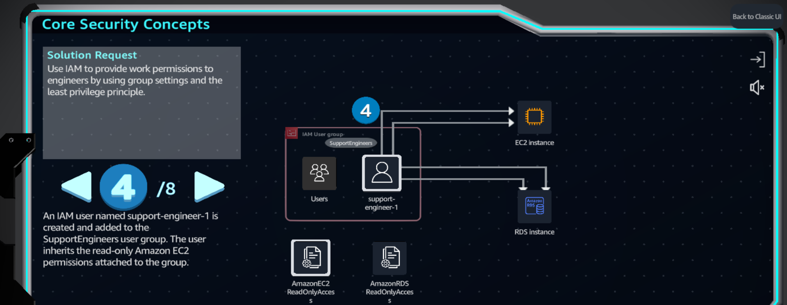 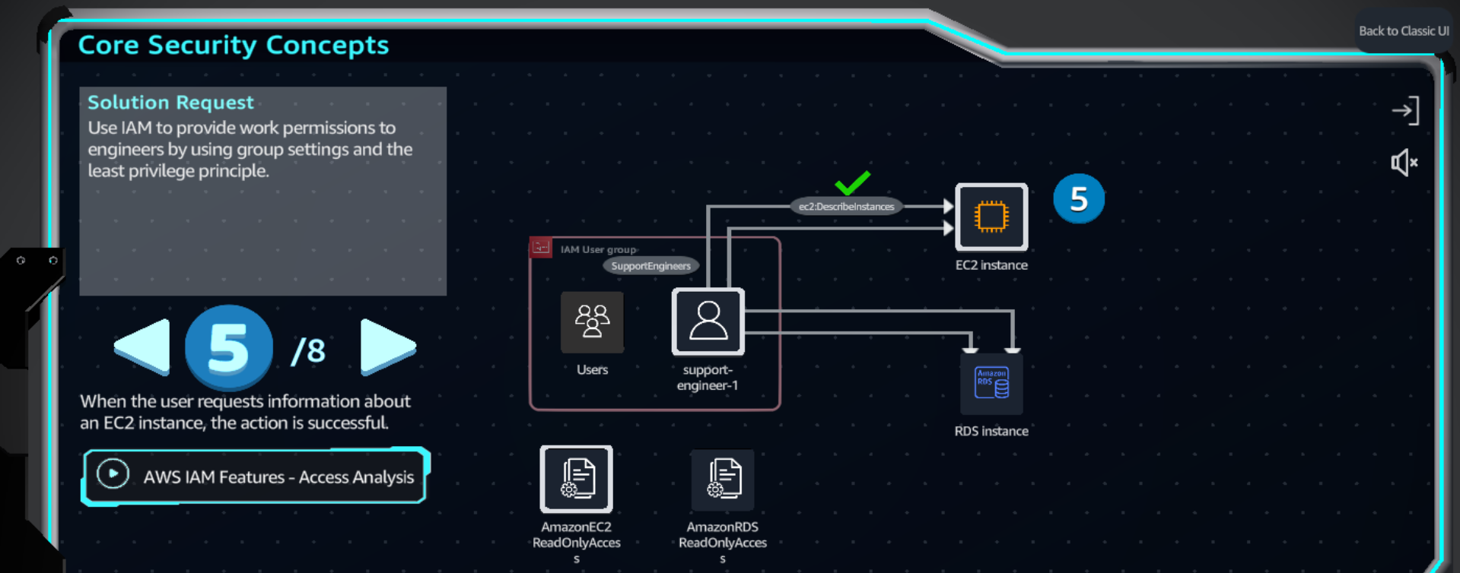 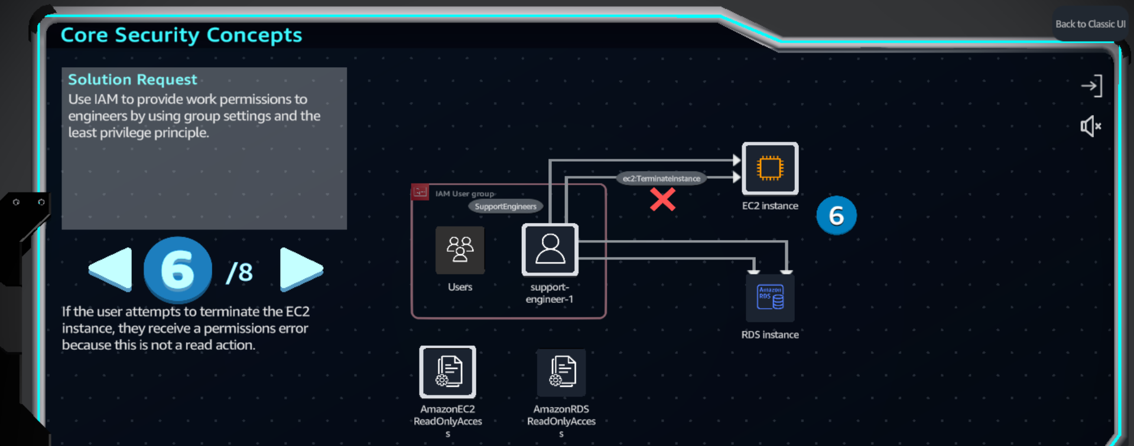 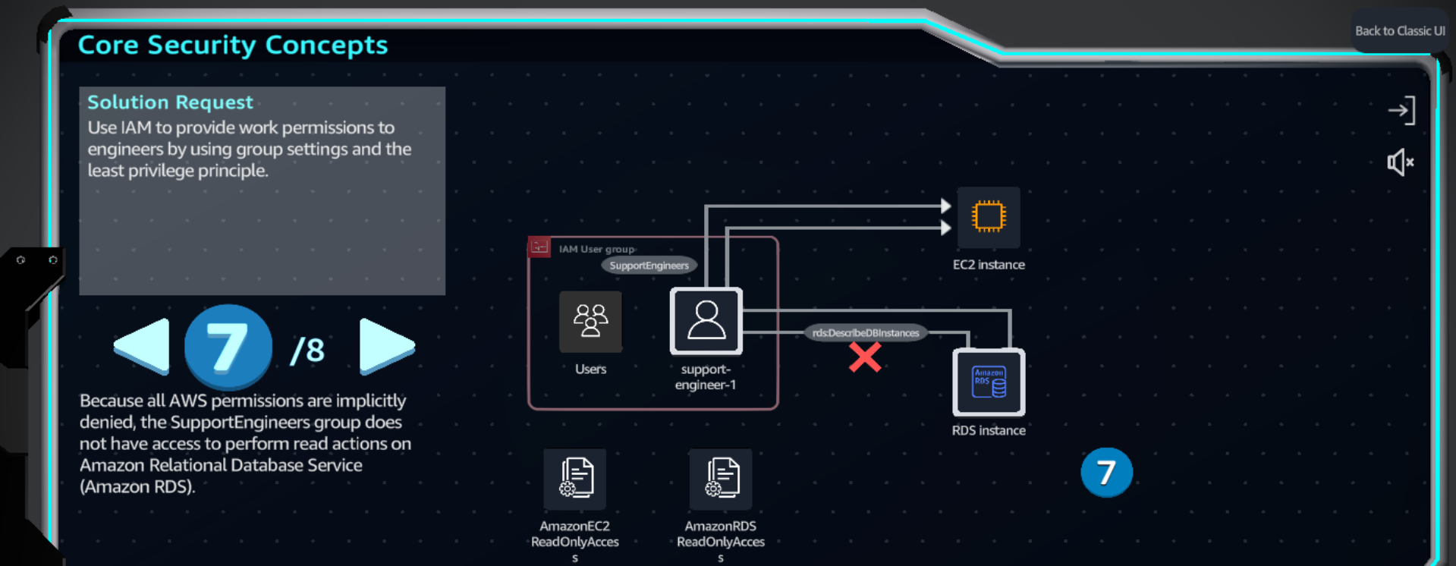 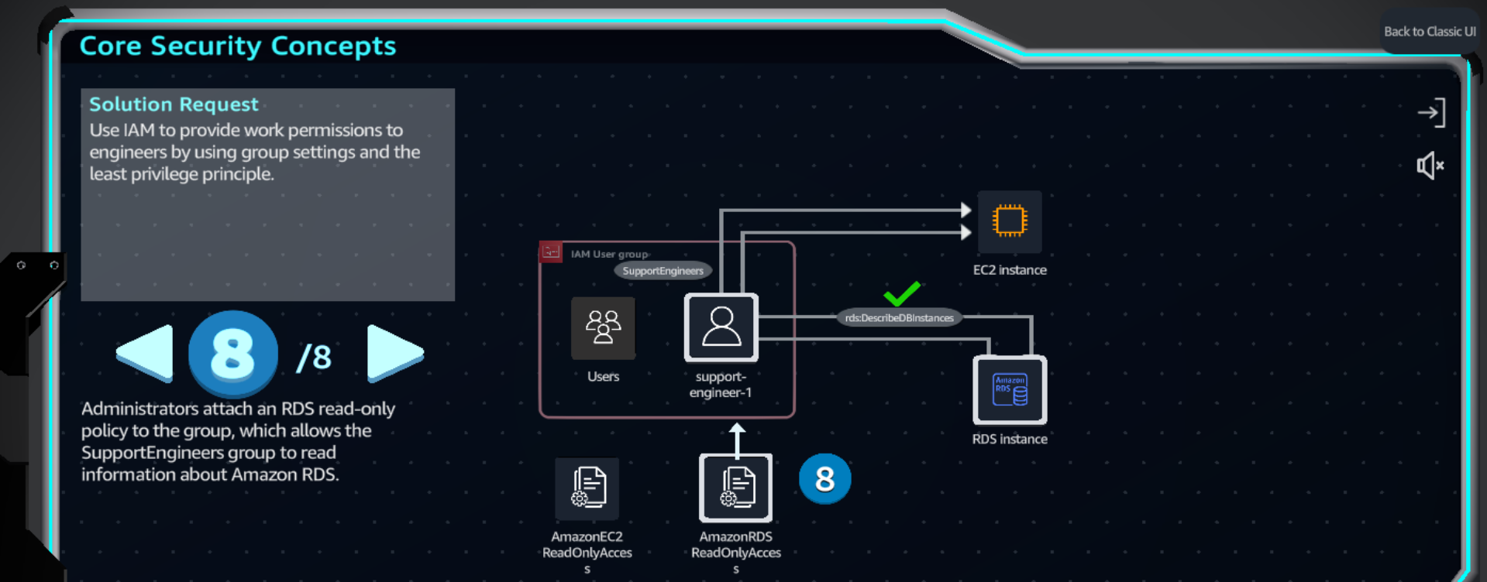

**Practice**

